|  |  |
| --- | --- |
|  | PT Bank BTPN Tbk |

JENIUS

E2E Architecture

This document contains information which is the property of PT Bank BTPN, Tbk. This document (including the parts in it) is not permitted to be disseminated, reproduced or transferred to parties other than PT Bank BTPN, Tbk. without written permission from the management of PT Bank BTPN, Tbk.

acknowledGEMENT & Review

|  |  |  |
| --- | --- | --- |
| Prepared By: | Signed | Date |
| Herendra  [IT Solution Architect] | Reviewed |  |

|  |  |  |
| --- | --- | --- |
| Reviewed By | Signed | Date |
| [IT Solution Architect Lead] |  |  |
| [IT Security Management Head] |  |  |
| [IT Data Architecture & Governance Head] |  |  |
| [IT Infrastructure Development Head] |  |  |
| [COS Integration] |  |  |
| [COS Common Services] |  |  |
| [COS Core] |  |  |
| [COS CC TFMS Lending] |  |  |
| [COS Payment] |  |  |
| [COS Sales] |  |  |
| [IT Special Project AML] |  |  |
| [IT Digital Banking & WMB Enabler] |  |  |

change history

| **Version** | **Date** | **Modified By** | **Explanation of Change** |
| --- | --- | --- | --- |
| 1.0 | dd/mm/yyyy |  | Initial version |

TABLE OF CONTENT

1 OVERVIEW 6

2 CAPABILITY MAP 7

3 INTEGRATION ARCHITECTURE 9

3.1 FRONT END SYSTEM 10

3.2 BACKEND SYSTEM 11

3.3 PARTNER 11

4 APPENDIX 13

# OVERVIEW

This document contains high level of jenius architecture. The architecture describe application and system component that enable and support Jenius services, capability map within enterprise, and integration within internal system and external parties. Documentation has been created by colaboration between IT and Jenius to provide necessary information to evaluate a variety of quality attribute such as performance, avaliability, usability, security and maintainability.

* This document can be referrence for:
* Develop or enhance new product / services which require architectural changes.
* Architecture Integration analysis to perform improvement and/or problem resolution.
* Reporting purposes for OJK/BI or SMBC.

To keep this document usefull, it is necessary to involve relevant stakeholders in maintaining the accuracy of the information in it.

# CAPABILITY MAP

*List of Application Used: AppBot​, AppsFlyer​, Bitbucket​, Bugsnag​, Firebase​, Jenkins, MailChimp​, NeverBounce​, New Relic​, Nexmo​, SKEDDA​, Slack​, SmartSheet​, Surge​, TestRail​, Typeform​, Zeplin

This diagram ilustrates the capabilities of bank btpn. The capability is managed and maintained by IT as part of the enterprise IT portfolio. The blue color indicate capabilities that directly involved in supporting jenius services.

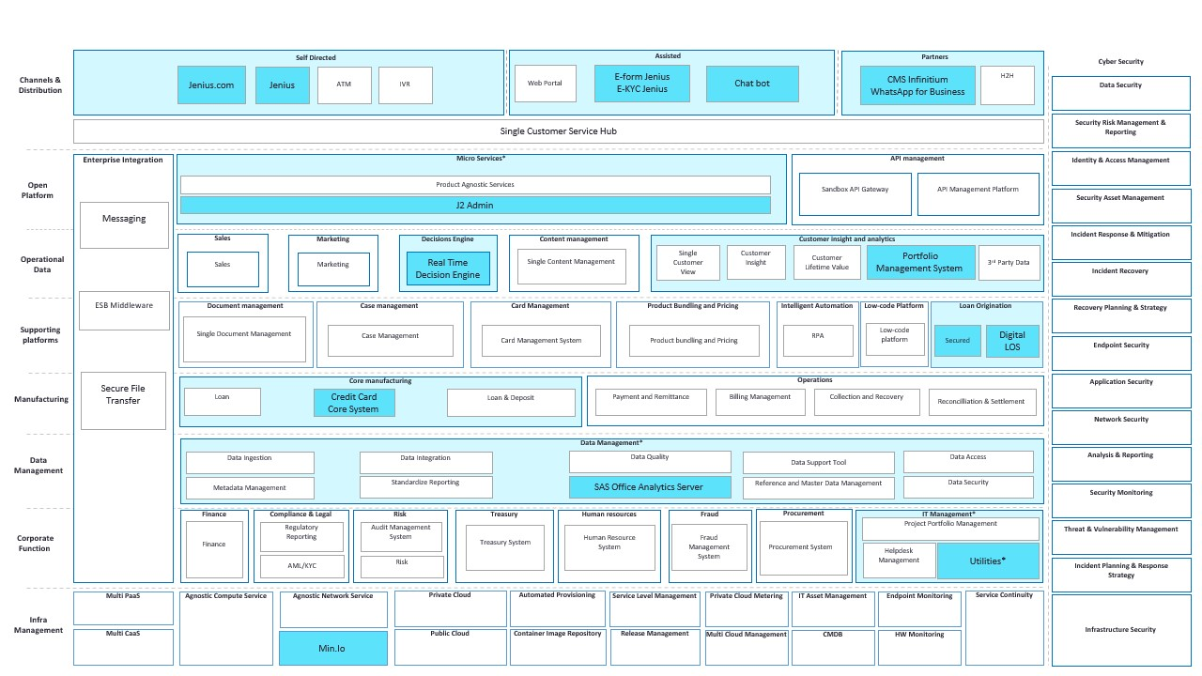

# INTEGRATION ARCHITECTURE



## FRONT END SYSTEM

This section explain more detail on application / system that used by customer.

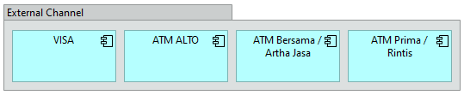

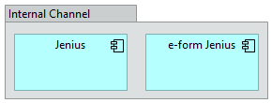

## BACKEND SYSTEM

This section explain more detail on backend system that realized the business services.

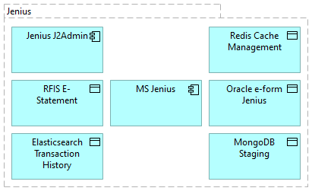

## PARTNER

This section explain more detail on application / system that used by customer.

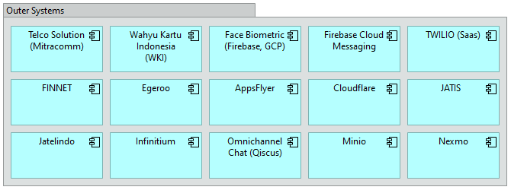

# APPENDIX

List of Application

|  |  |  |  |
| --- | --- | --- | --- |
| **APP_ID** | **APPLICATIONNAME** | **DESCRIPTION** | **RANK** |
| sdb-cba-s1 | Jenius | BTPN Digital Banking application equipped with Visa debit card with highlighted feature. | A |
| sdb-cba-s2 | jenius.com | Jenius web application to publish information related to products, services and job vacancies. | B |
| sdb-csu-s3 | Chatbot | An integrated and automated system to provide responses to inquiries, complaints, and customer requests without or through a Jenius agent. | N/A |
| sdb-cbu-s1 | e-form Jenius | Applications to replace hardcopy form into electronic form, namely for opening a new account in Jenius. | B |
| sdb-cbu-s4 | E-KYC (Jenius) | Applications that are used to record customer data from the face-to-face process between bank officers and customers at the time of opening a new account. | B |
| sdb-csu-s1 | CMS Infinitium | CMS Infinitium is a payment system product designed for banks, to provide comprehensive verification and authentication capabilities for Card-Not-Present (CNP) transactions using 3D Secure 1.0 and 3D Secure 2.0 in one platform. Authentication for payments, especially for CNP such as E-commerce, M-commerce and MOTO (Mail Order Telephone Order). | N/A |
| sdb-csu-s2 | WhatsApp for Business | Whatsapp account for business for BTPN | N/A |
| sdb-uti-s1 | J2 Admin | Web application that is used to perform variety of Administrative and Configuration tasks for Jenius App. |  |
| sdb-ids-s2 | Portfolio Management System | The application automates the implementation of the credit policy strategy for flexy cash: Authorization Strategy, renewal, Limit management, and customer block code from what was originally done manually using SAS to be processed by PCCM. And the application aggregates data on the data variables needed for the strategy from what was originally provided manually by MIS/IT to be processed by PCCM. | B |
| sdb-cba-cl11 | AppBot | An online platform that makes it easy to analyze customer comments and understand customer experiences. | N/A |
| sdb-cba-cl10 | AppsFlyer | Application for analyzing Jenius customer behavior. | N/A |
| sdb-cba-cl5 | Bitbucket | Application that Holds the source code of the Jenius application. | N/A |
| sdb-cba-cl8 | Bugsnag | Application error reporting (Development Phase). Jenius mobile apps notification services and dashboard. | N/A |
| sdb-cba-cl16 | Firebase | The application is used to send notifications based on the registered device-ID through the Jenius application (in-app notifications). | N/A |
| sdb-cba-cl6 | Jenkins | Application that connecting the process from source code which done by the developer to the tests conducted by the QA team. | N/A |
| sdb-cba-cl12 | MailChimp | Application used to send email blasts to Jenius customers. | N/A |
| sdb-cba-cl13 | NeverBounce | Realtime customer email verification service application and email cleaning service is inactive. | N/A |
| sdb-cba-cl14 | New Relic | Application to monitor the performance and constraints of the Jenius system. | N/A |
| sdb-cba-cl17 | Nexmo | Application to send OTP SMS (only for onboarding customers) to Jenius customers. | N/A |
| sdb-cba-cl18 | SKEDDA | Application that is used to record the schedule of room usage that will be used by the Jenius team. | N/A |
| sdb-cba-cl9 | Slack | Application is used for Jenius internal communication. | N/A |
| sdb-cba-cl4 | SmartSheet | Application that functions as a project management system for non app projects. | N/A |
| sdb-cba-cl7 | Surge | Application that allows developers to present Web applications (Internet Banking) to the QA team for testing. | N/A |
| sdb-cba-cl2 | TestRail | Application used to collect test results and test cases conducted by the QA team. | N/A |
| sdb-cba-cl1 | Typeform | An online platform that can assist in the improvement of suggestions from respondents selected as Jenius's improvement material. Used to make online surveys and assist in gathering insights and feedback from Jenius customers. | N/A |
| sdb-cba-cl3 | Zeplin | Tools used by the UI / UX Team to create screen designs that will be implemented in the Jenius application. | N/A |
| sdb-ids-s1 | SAS Office Analytics Server | Application to conduct analytics including gather, prepare and manage data, perform meaningful analyses and easily share results using familiar Microsoft Office applications – Excel, Word, PowerPoint and Outlook email. | B |
| sdb-inf-s1 | Min.Io | A system for storing files (object storage) to support Jenius Apps Services | TBD |
|  |  |  | TBD |
| dlen-cbu-s1 | Real Time Decision Engine | Bank wide system to automate credit decisioning process by implementing realtime credit scoring, policy, and rules for bank’s loan product | B |
| dlen-cbu-s2 | Digital LOS | Bank wide digital loan originating system that automates loan application and underwriting process. This application is built on the top Outsystem platform using BPT component. | A |
| bnk-cba-s4 | Credit Card Core System | A Credit Card Core system supports Bank Card Processing, as an issuer. The system able to administer card-related data for BTPN include and not limited to account enrollment, card creation, card personalization preparation, product/account/transaction maintenance, billing statements, payments, collection systems, customer care (CRM & CEC) and so forth. | A |